MONTAGUE PLACE, WORPLESDON – ARTIST BRIEF

AIM:
To create site specific public art to enhance the residential development at Montague Place, Worplesdon.

BACKGROUND:
Taylor Wimpey are building a residential development on a site north of Keens Lane in Worplesdon, Guildford. As part of the planning process Taylor Wimpey wishes to commission an artist to create a piece of public art to complement the development and surrounding area.

BRIEF FOR ARTWORK:
We would like to see proposals for public art which complement the new residential development and reflect the history of the area.

We have a suitable spot on an area of Public Open Space (as highlighted below) or we would also consider multiple pieces of smaller art spread across the estate. The site’s former use included a riding school, allotments and farmland, and prior to this extraction for brick manufacturing. The site also has local wildlife which includes a low population of great crested newts, bats and badgers although we would welcome all ideas for the art project.

Taylor Wimpey would welcome all submissions of art including sculptures, paintings, woodwork or artwork incorporated into the landscaping.

The designs should reflect the history and character of the area and take into account considerations such as longevity of the artwork, ease of maintenance, health and safety and vandalism risks.

Taylor Wimpey will have ownership of outputs, including the final piece of artwork.

SELECTION PROCESS:
This brief will be advertised locally. Artists should respond initially with a CV and pictures of previous work along with sketches and/or an outline for a design proposal. Shortlisted artists will then be asked to produce a detailed design proposal which will be reviewed by a panel including representatives of the Worplesdon Parish Council, Guildford Borough Council, Taylor Wimpey and Guildford Public Arts Advisory Group.

BUDGET AND PAYMENT:
The fixed budget for this commission will be £7,500, which must include all artist fees and expenses, design development, prototypes, installation and fabrication costs. The fee will be paid in instalments as agreed between Taylor Wimpey and the artist. Taylor Wimpey will look to provide a suitable platform for the art and may contribute to materials for fabrication and installation subject to further discussion and agreement.

HEALTH AND SAFETY:
The chosen artist will be required to complete a risk assessment for artwork and installations.

The artist should consider public safety and the possibility of vandalism when designing artwork and choosing materials. Artist to give recommendations for repair and cleaning and estimate costs for maintenance.

TIMESCALE:
CVs and expressions of interest should be returned by 15th December 2020. The shortlisted artists are to be notified by 15th January 2021. Shortlisted design proposals will need to be submitted by 5th February with an artist appointment later within the month of February.

Public art installation dates are subject to further discussion between the appointed artist and Taylor Wimpey.

LOCATION:
A suggested location for the public art is highlighted below in yellow, however depending upon the type of artwork an alternative location or locations may be agreed.
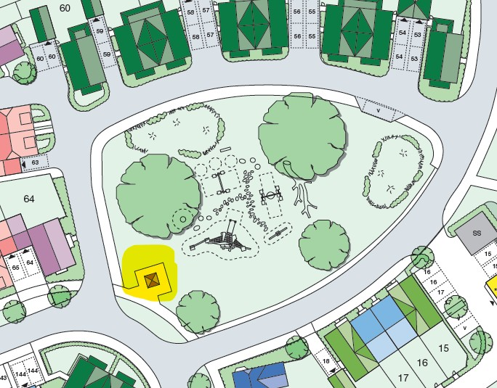

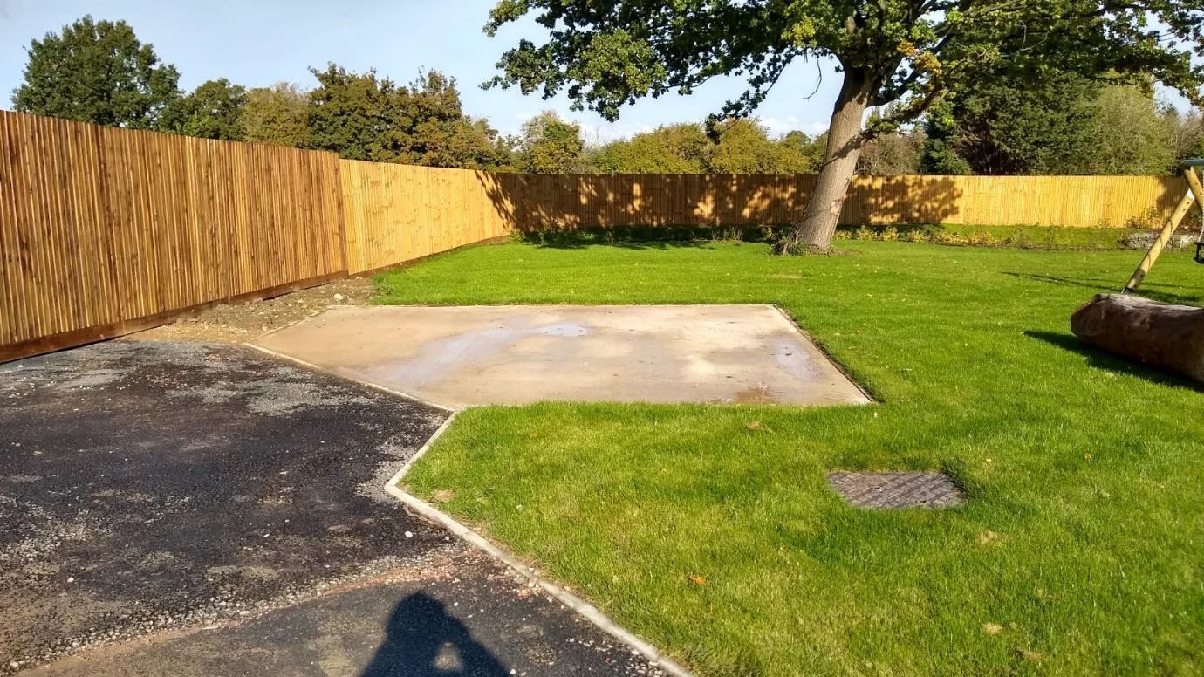

CONTACT AND EXPRESSIONS OF RETURN:
Jonathan Bowler | Senior Technical Co-ordinator | Taylor Wimpey South Thames Email: Jonathan.Bowler@taylorwimpey.com
Tel: 01372 385847

